1. CREATE TABLE Dept (Dept_id INT PRIMARY KEY,Dept_name VARCHAR(50) NOT NULL,Dept_location VARCHAR(50));

[Execution complete with exit code 0]

1. CREATE TABLE Employee (Emp_id INT PRIMARY KEY, Dept_id INT, Emp_fname VARCHAR(50), Emp_lname VARCHAR(50), Emp_Position VARCHAR(50), Emp_salary DECIMAL(10,2), Emp_JoinDate DATE, CONSTRAINT fk_dept_emp FOREIGN KEY (Dept_id) REFERENCES Dept(Dept_id) ON DELETE CASCADE);

[Execution complete with exit code 0]

1. CREATE TABLE Project (Proj_id INT PRIMARY KEY, Dept_id INT, Proj_Name VARCHAR(50), Proj_Location VARCHAR(50), Proj_cost DECIMAL(12,2), Proj_year INT, CONSTRAINT fk_dept_proj FOREIGN KEY (Dept_id) REFERENCES Dept(Dept_id) ON DELETE CASCADE);

[Execution complete with exit code 0]

1. INSERT INTO Dept VALUES(1, 'Computer', 'Delhi'),(2, 'IT', 'Pune'), (3, 'HR', 'Mumbai'),(4, 'Finance', 'Chennai');

1. INSERT INTO Employee VALUES

(101, 1, 'Pankaj', 'Sharma', 'Manager', 50000, '1980-06-12'),

(102, 2, 'Harsh', 'Mehta', 'Developer', 45000, '1984-03-20'),

(103, 3, 'Ravi', 'Kumar', 'Analyst', 35000, '1990-04-12'),

(104, 4, 'Neha', 'Joshi', 'Clerk', 25000, '1995-12-01'),

(105, 1, 'Priya', 'Singh', 'Tester', 30000, '2001-09-09'),

(106, 2, 'Hitesh', 'Patel', 'Developer', 47000, '1998-08-25'),

(107, 2, 'Komal', 'Verma', 'Manager', 55000, '1992-05-10'),

(108, 3, 'Amit', 'Jain', 'HR', 40000, '1987-11-23'),

(109, 4, 'Sneha', 'Bose', 'Clerk', 27000, '1994-02-15'),

(110, 1, 'Prateek', 'Kapoor', 'Support', 32000, '2000-07-19');

1. INSERT INTO Project VALUES

(201, 1, 'ERP Upgrade', 'Pune', 300000, 2004),

(202, 2, 'CyberSecure', 'Delhi', 150000, 2005),

(203, 1, 'CloudShift', 'Mumbai', 500000, 2007),

(204, 3, 'RecruitSys', 'Chennai', 80000, 2002),

(205, 4, 'FinTrack', 'Pune', 420000, 2004);

1. SELECT * FROM Employee JOIN Dept ON Employee.Dept_id = Dept.Dept_id WHERE Dept.Dept_name IN ('Computer', 'IT') AND (LOWER(Employee.Emp_fname) LIKE 'p%' OR LOWER(Employee.Emp_fname) LIKE 'h%');

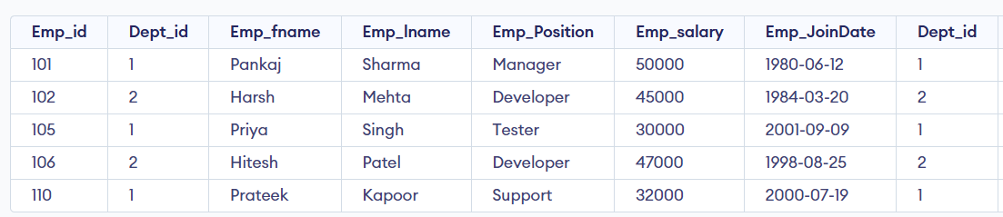

1. Increase salary by 10% for employees who joined before 1985

UPDATE Employee SET Emp_salary = Emp_salary * 1.10

WHERE EXTRACT(YEAR FROM Emp_JoinDate) < 1985;

1. Delete department located in Mumbai

DELETE FROM Dept WHERE Dept_location = 'Mumbai';

1. Projects located in Pune

SELECT Proj_Name FROM Project WHERE LOWER(Proj_Location) = 'pune';

1. Projects with cost between 100000 and 500000

SELECT * FROM Project

WHERE Proj_cost BETWEEN 100000 AND 500000;

1. Project with maximum cost and average project cost

SELECT Proj_Name, Proj_cost

FROM Project

WHERE Proj_cost = (SELECT MAX(Proj_cost) FROM Project);

SELECT AVG(Proj_cost) AS Avg_Cost FROM Project;

1. Display all employees ordered by last name descending

SELECT Emp_id, Emp_fname || ' ' || Emp_lname AS Emp_Name

FROM Employee

ORDER BY Emp_lname DESC;

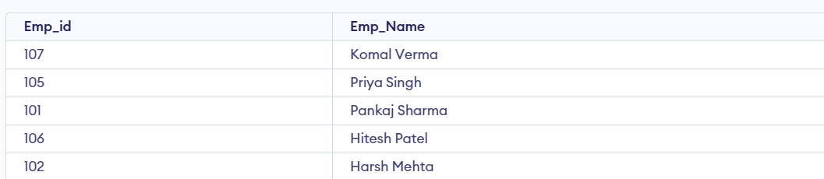

1. Projects started in 2004, 2005, or 2007

SELECT Proj_name, Proj_location, Proj_cost

FROM Project

WHERE Proj_year IN (2004, 2005, 2007);

Create Index, View, Sequence, and Synonym

Index on Emp_lname

1. CREATE INDEX idx_emp_lname ON Employee(Emp_lname);
2. CREATE VIEW Emp_Dept_View AS SELECT E.Emp_id, E.Emp_fname, E.Emp_lname, D.Dept_name, E.Emp_Position FROM Employee E JOIN Dept D ON E.Dept_id = D.Dept_id;
3. CREATE SEQUENCE emp_seq START WITH 111 INCREMENT BY 1;
4. INSERT INTO Employee (Emp_id, Dept_id, Emp_fname, Emp_lname, Emp_Position, Emp_salary, Emp_JoinDate) VALUES (emp_seq.NEXTVAL, 1, 'Rohan', 'Das', 'Tester', 29000, '2003-01-01');